COFFEE SHOP SALES

KPI’s

1. Total Revenue

/* Total Revenue As we do not have TOTALPrice column so to calculate TOTALREVENUE use below formula */

SELECT

SUM(unit_price * transaction_qty) AS TotalRevenue

FROM

CoffeeShop;

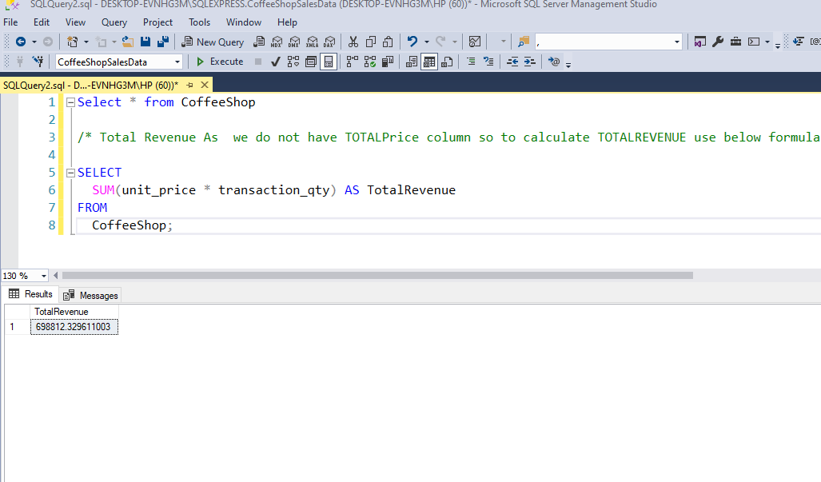

1. AverageOrderValue

/* Avereage Order value , so it might happen that we have duplicates

or can say we have many transaction ids same according to the order placed by customers

so to extract only the DISTINCT(Unique values ) we should use CountofDistinct values. */

SELECT

SUM(unit_price * transaction_qty) / COUNT(DISTINCT transaction_id) AS AVERAGE_ORDER_VALUE

FROM

CoffeeShop;

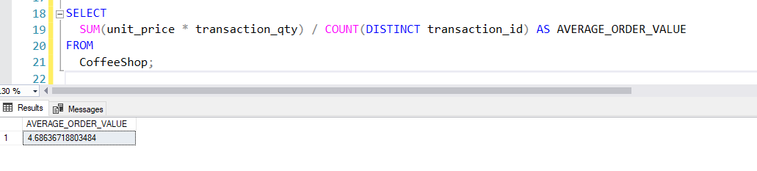

1. TotalProductSold

/* Total Product Sold */

SELECT

SUM(transaction_qty) AS Total_Product_SOLD

FROM CoffeeShop;

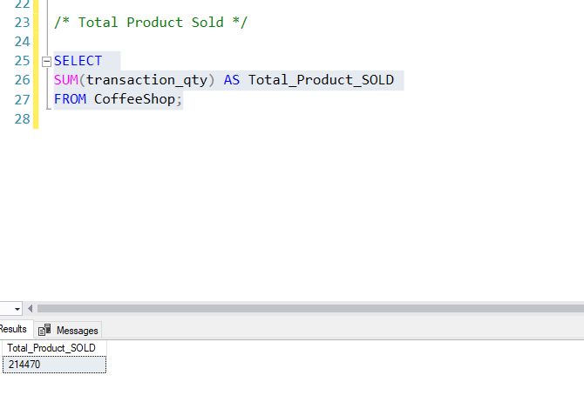

1. TotalOrder

/* Total Orders */

SELECT

Count(Distinct transaction_id) AS Total_Orders

FROM CoffeeShop;

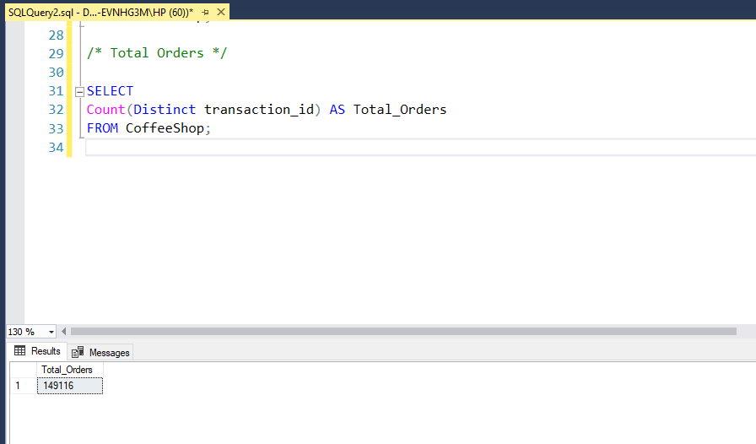

1. AverageProductPerSales

Select CAST(

CAST( SUM(transaction_qty)AS DECIMAL(10,2))/

CAST(COUNT(Distinct transaction_id)AS DECIMAL(10,2)) AS DECIMAL(10,2)) Avg_Product_perorder

From CoffeeShop;

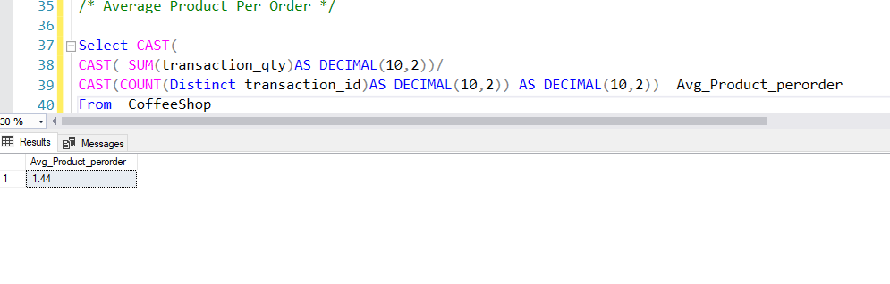

1. Daily Trends of Orders (Day-wise)

Select

DATENAME(DW,transaction_date) AS Order_Day,

COUNT(DISTINCT transaction_id) AS Total_Orders

FROM CoffeeShop

GROUP BY DATENAME(DW,transaction_date);

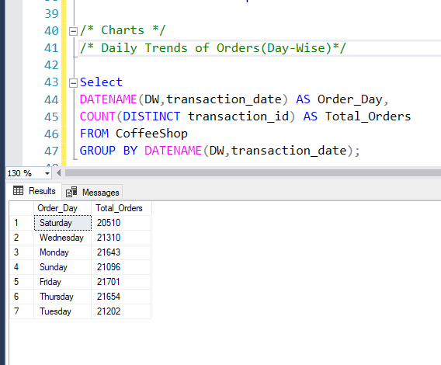

1. Monthly Trends of Orders (Month-Wise)

SELECT DATENAME(Month,transaction_date) AS Order_Month ,

COUNT(DISTINCT transaction_id) AS Total_Orders

FROM CoffeeShop

GROUP BY DATENAME(Month ,transaction_date)

ORDER BY Total_Orders;

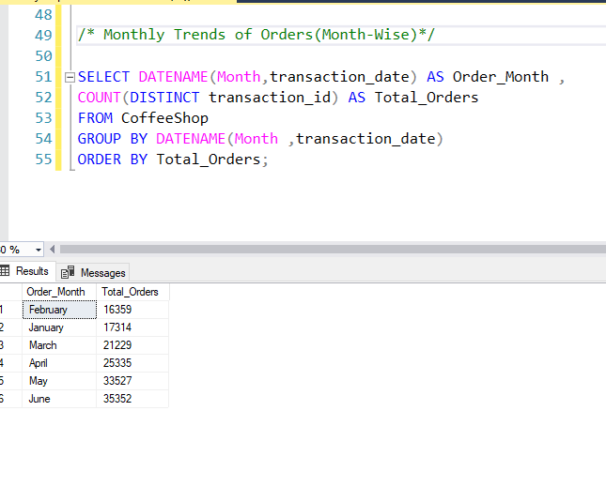

1. % of Total Sales

/* % of sales */

Select product_category,

SUM(unit_price * transaction_qty)*100/

(SELECT SUM(unit_price * transaction_qty) FROM CoffeeShop) AS PercentageofTotalSales

FROM CoffeeShop

Group by product_category;

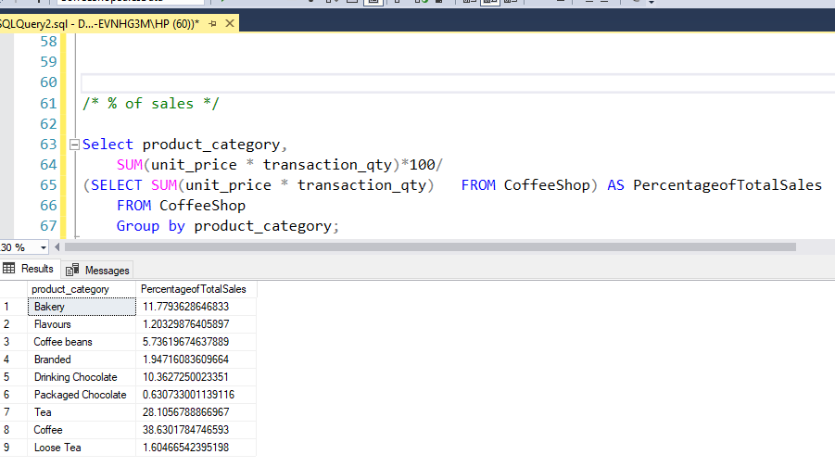

* 1. Percentage of Total Sales With Filter of MONTH(January-December)

/* If we want to filter the data according to the MONTH (January=1……… December=12) than use below query in subquery*/

Select product_category,

SUM(unit_price * transaction_qty)*100/

(SELECT SUM(unit_price * transaction_qty) FROM CoffeeShop WHERE MONTH(transaction_date)=1 )

AS PercentageofTotalSales

FROM CoffeeShop

WHERE MONTH(transaction_date)=1

Group by product_category;

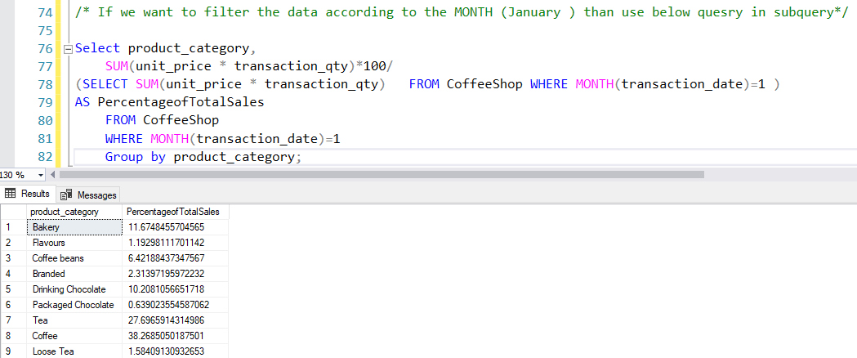

1. Percentage of Sales by Product Size

Select Size,

SUM(unit_price * transaction_qty) AS TOtalSales ,

SUM(unit_price * transaction_qty)*100/

(SELECT SUM(unit_price * transaction_qty) FROM CoffeeShop) AS PercentageofTotalSize

FROM CoffeeShop

Group by Size

Order by PercentageofTotalSize DESC ;

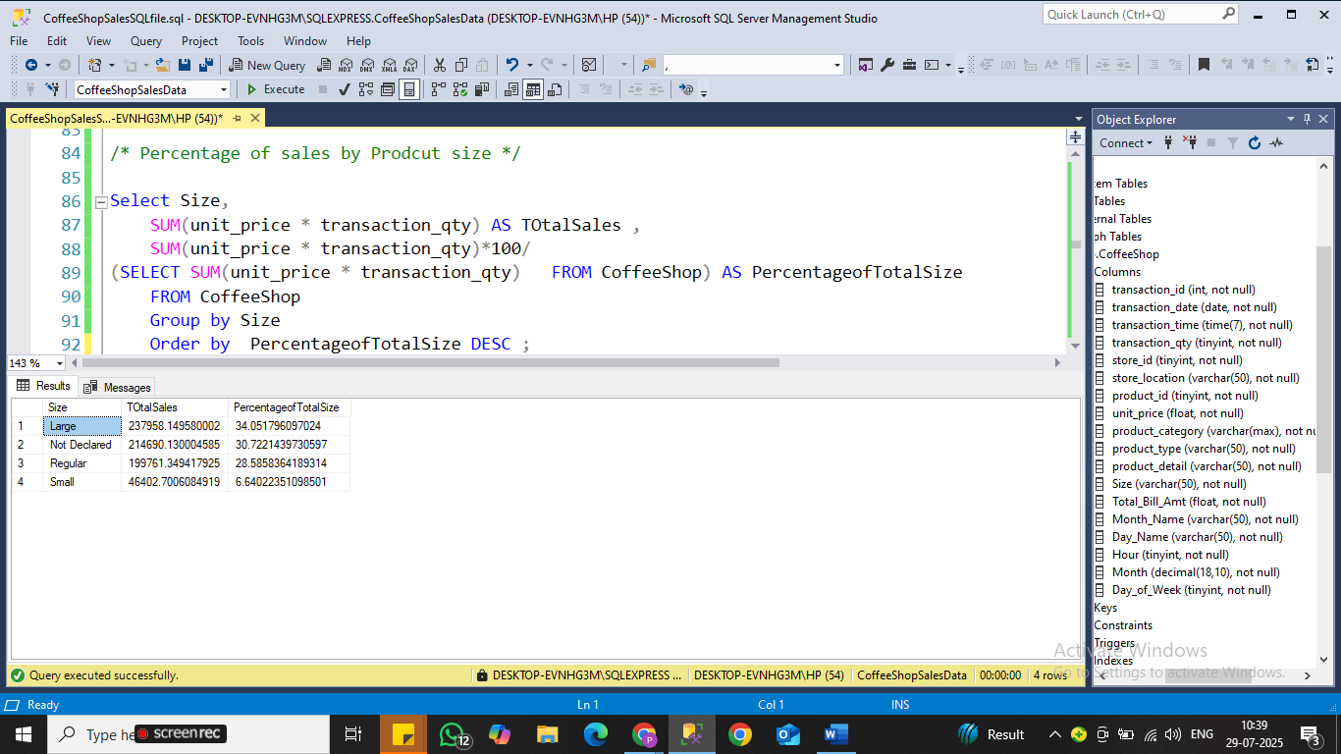

* 1. Removing Decimals upto (10,2)

/* for removing decimals or just for two decimals */

Select Size,

CAST(SUM(unit_price * transaction_qty)AS DECIMAL(10,2)) AS TOtalSales ,

CAST(SUM(unit_price * transaction_qty) *100/

(SELECT SUM(unit_price * transaction_qty) FROM CoffeeShop) AS DECIMAL(10,2)) AS PercentageofTotalSize

FROM CoffeeShop

Group by Size

Order by PercentageofTotalSize DESC ;

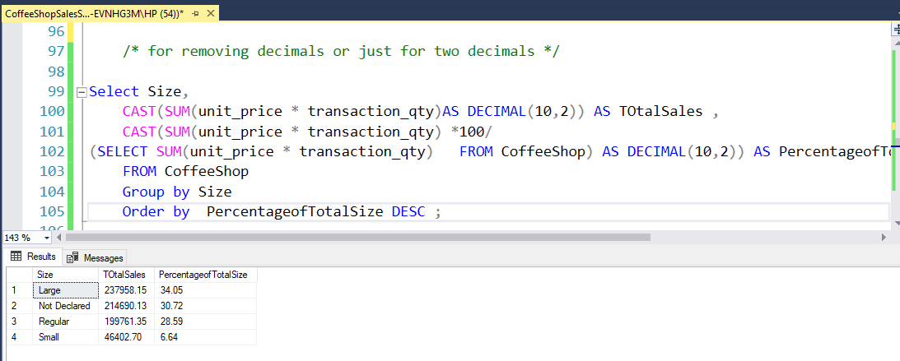

* 1. For quarter

/* Filtering it for Quarter*/

Select Size,

CAST(SUM(unit_price * transaction_qty)AS DECIMAL(10,2)) AS TOtalSales ,

CAST(SUM(unit_price * transaction_qty) *100/

(SELECT SUM(unit_price * transaction_qty)

FROM CoffeeShop) AS DECIMAL(10,2)) AS PercentageofTotalSize

FROM CoffeeShop

WHERE DATEPART(QUARTER,transaction_date)=1

Group by Size

Order by PercentageofTotalSize DESC ;

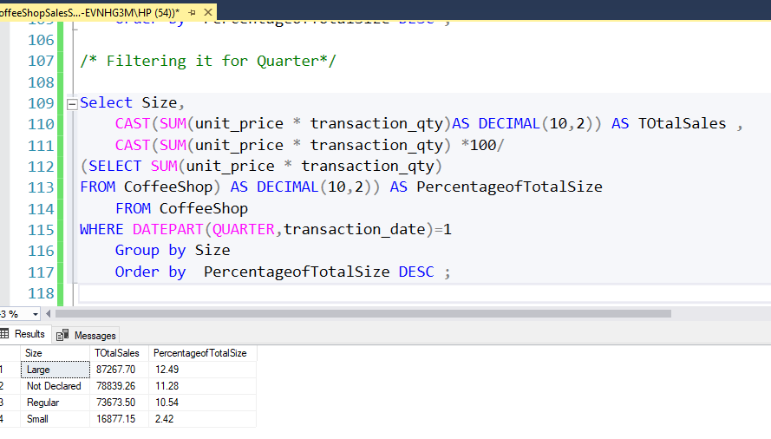

1. Total Revenue of products according to the Product_category

/* To see what is the revenue the products are giving to us*/

Select product_category ,

sum (unit_price*transaction_qty) as TotalRevenue

from Coffeeshop

group by product_category

order by TotalRevenue DESC;

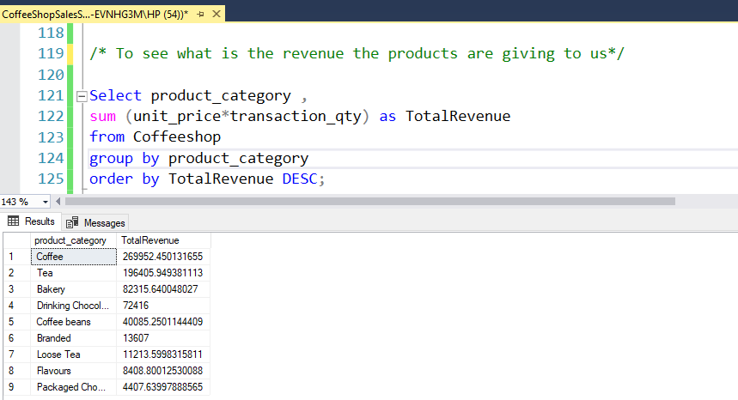

1. Top 5 & Bottom 5 according to the totalRevenue

/* Top 5 Product */

Select TOP 5 product_category ,

sum (unit_price*transaction_qty) as TotalRevenue

from Coffeeshop

group by product_category

order by TotalRevenue DESC;

/* Bottom 5 products according to the total revenue */

Select TOP 5 product_category ,

sum (unit_price*transaction_qty) as TotalRevenue

from Coffeeshop

group by product_category

order by TotalRevenue ASC

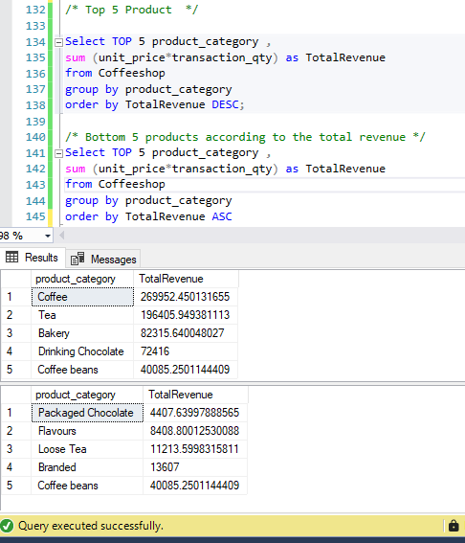

1. Top 5 & Bottom 5 according to the quantity

/* Top 5 products according to the quantity */

select TOP 5 product_category,

SUM(transaction_qty) AS Totalquantity

from CoffeeShop

group by product_category

Order by Totalquantity Desc;

/* Bottom 5 products according to the quantity */

select TOP 5 product_category,

SUM(transaction_qty) AS Totalquantity

from CoffeeShop

group by product_category

Order by Totalquantity Asc;

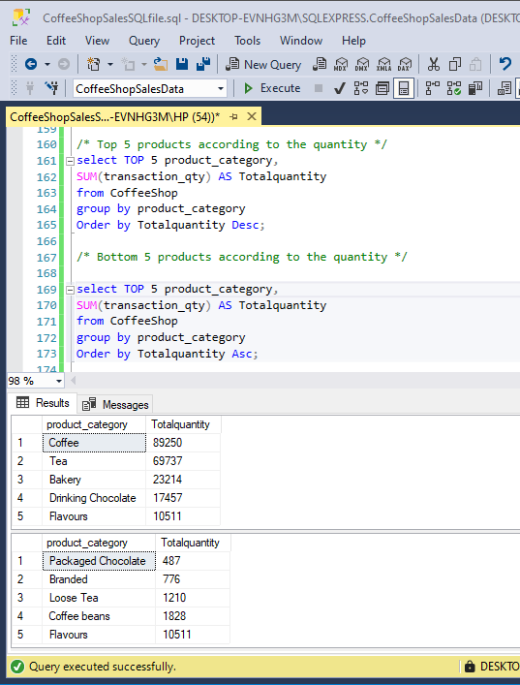

1. Top 5 & Bottom 5 according to the transaction_id(quantity)

/* Top 5 products according to the transactionid(orders) */

select TOP 5 product_category,

Count(DISTINCT transaction_id) AS TotalOrders

from CoffeeShop

group by product_category

Order by TotalOrders Desc;

/* Bottom 5 products according to the transactionid(orders) */

select TOP 5 product_category,

Count(DISTINCT transaction_id) AS TotalOrders

from CoffeeShop

group by product_category

Order by TotalOrders Asc;

